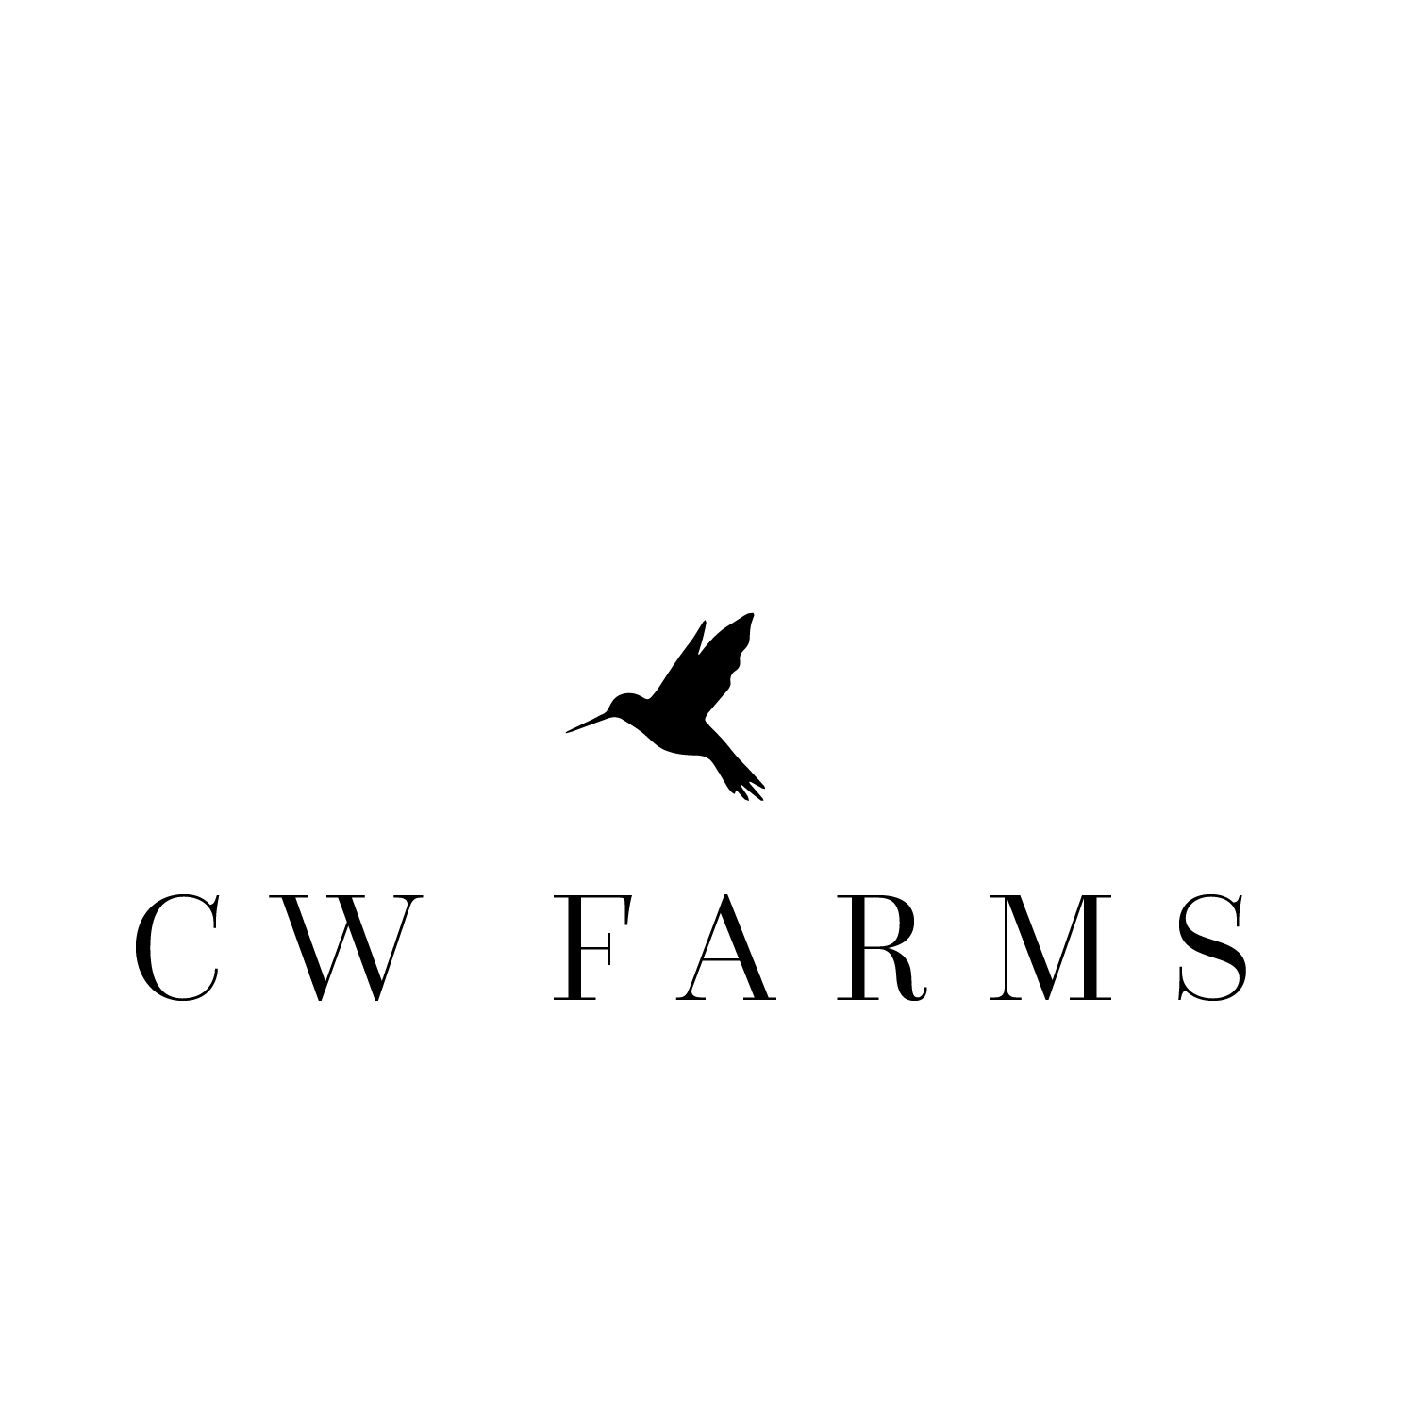

**CW Farms, LLC**

30673 Andreen Road

Valley Center, CA 92082

(858) 204-0554

INDEMNITY/LIABILITY RELEASE

By this agreement, made and entered this _____ day of _______________ 20_____, by and between ____________________________________ who resides at ____________________________________ hereinafter referred to as “I” and “CW Farms, LLC,” 30673 Andreen Road, Valley Center, CA 92082.

**IT IS HEREBY AGREED TO AS FOLLOWS:**

1. That I, the undersigned, do for myself or on behalf of my child or legal ward, hereby voluntarily request to participate in riding instruction and or activities as a rider(s) at CW Farms. I or the student will ride his or her own horse or school horses boarded at CW Farms.
2. That I, the undersigned, do for myself or on behalf of my child or legal ward, understand that horseback riding is a hazardous activity and that horses are unpredictable by nature; that when frightened or angry or under stress, a horse’s natural instincts are to jump forward or sideways, to run away from danger at a trot or a gallop, to kick, to buck, to rear up in front, or to bite; that horses are extremely powerful; and that if a rider falls to the ground, the fall distance will be generally from 3-1/2 to 5-1/2 feet. I understand these risks, and I voluntarily assume these risks and dangers.
3. That I, the undersigned, do for myself or on behalf of my child or legal ward, understand that upon mounting the horse and taking up the reins, the rider is in primary control of the horse and that CW Farms is not responsible for the results of the rider’s actions or omissions. The rider further agrees not to abuse, misuse or deliberately agitate the horse as these actions may result in increased risk to the rider and/or others.
4. That I, the undersigned, do for myself or on behalf of my child or legal ward, understand that riders should purchase and wear a helmet or hard hat and appropriate protective footwear at all times. Riders under the age of 18 years are required to wear a helmet or hard hat at all times while riding on or using CW Farms grounds and facilities. Riders 18 years of age or older are required to wear a helmet or hard hat whenever using any jump, natural or man-made, on CW Farms grounds. I acknowledge that I have been informed regarding the hazards of head injury while riding without a helmet.
5. **LIABILITY RELEASE:** THAT I, THE UNDERSIGNED, DO FOR MYSELF OR ON BEHALF OF MY CHILD OR LEGAL WARD, UNDERSTAND THAT I AM RESPONSIBLE FOR BODILY INJURY OR PROPERTY DAMAGE WHICH I OR MY CHILD OR LEGAL WARD SHOULD SUSTAIN ON THE CW FARMS PREMISES AND/OR TRAILS AND/OR WHILE RIDING A HORSE, AND/OR WHILE RIDING IN A COURSE OF INSTRUCTION, AND FOR ANY TIME I OR MY CHILD OR LEGAL WARD SHALL LOSE FROM EMPLOYMENT OR SCHOOL OR ACTIVITY, AND FOR MEDICAL EXPENSES OR ANY OTHER EXPENSES INCURRED BECAUSE OF SUCH BODILY INJURY OR PROPERTY DAMAGE: AND THAT I HEREBY, FOR MYSELF, MY HEIRS, CHILD, LEGAL WARD, ADMINISTRATORS AND ASSIGNS RELEASE AND DISCHARGE CW FARMS LLC, ITS DIRECTORS, CREDITORS, OPERATORS AND SPONSORS OF CW FARMS LLC AND THEIR RESPECTIVE SERVANTS, AGENTS, OFFICERS, EMPLOYEES AND ALL OTHER PARTICIPANTS, OF AND FROM ALL CALIMS, DEMANDS, ACTIONS AND CAUSES OF ACTION FOR SUCH INJURIES SUSTAINED TO MY PERSON, OR THAT OF MY CHILD OR LEGAL WARD AND/OR PROPERTY, EXCEPT AS MAY BE CAUSED BY CW FARMS’ WANTON AND WILLFUL NEGLIGENCE. I HEREBY AGREE TO ACCEPT ANY AND ALL RISKS OF BODILY INJURY AND VERIFY THIS STATEMENT BY PLACING MY INITITALS HERE: _____
6. **INDEMITY:** I AGREE TO INDEMNIFY AND PAY ANY EXPENSES, LOSS OR DAMAGE THAT IS INCURRED BY CW FARMS LLC, ITS OFFICERS, DIRECTORS, CREDITORS, SERVANTS, AGENTS AND EMPLOYEES OF CW FARMS LLC ARISING OUT OF RIDING A HORSE AND/OR WHILE IN TRANSIT, OR AT A HORSE SHOW, TRAIL RIDE OR SIMILAR EXPEDITION OR IN COURSE OF INSTRUCTION, THAT I, MY CHILD OR LEGAL WARD SHALL INCUR. I AGREE TO THE FOREGOING BY PLACING MY INITITALS HERE: _____
7. **INDEMNITY/LIABILITY RELEASE BY PARENT OR GUARDIAN OF MINOR CHILD/WARD:** IN THE KNOWLEDGE THAT A PARENT, BY LAW, CANNOT WAIVE THE PERSONAL INJURY RIGHTS OR OTHER CLAIMS OF A (THEIR) MINOR CHILD/WARD, THE UNDERSIGNED PARENT OR GUARDIAN OF SAID MINOR CHILD/WARD AGREES TO INDEMNIFY CW FARMS LLC, ITS OFFICERS, DIRECTORS, CREDITORS, SERVANTS, AGENTS AND EMPLOYEES FROM ANY FINANICAL LOSS SUFFERED AS A RESULT OF ANY CLAIM BROUGHT ON BEHALF OF SAID MINOR CHILD/WARD.
8. A) That the rider is currently covered by accidental-medical insurance and will remain insured for the duration of all riding instruction at CW Farms: Yes No

Name of insurance Company: ___________________________________

Phone: ___________________________

Policy No: ________________________

B) Person to contact in emergency

Name _________________ Phone _________________ Relation ______________

Name _________________ Phone _________________ Relation ______________

1. That this agreement is entered into in the state of California and will be interpreted and enforced under the laws of that state.
2. Upon signing this agreement, rider acknowledges that he/she has read and agrees to be bound by CW Farms LLC “Riding Rules and Policies,” attached as “Exhibit A” and incorporated herein by this reference.

**I, THE UNDERSIGNED, BEING OF LEGAL AGE AND OF SOUND MIND AND NOT BEING UNDER THE INFLUENCE OF ALCOHOL, DRUGS OR INTOXICANTS, HAVE READ AND UNDERSTAND THE FOREGOING AGREEMENT AND RELEASE. I ALSO ACKNOWLEDGE RECEIPT OF A COPY OF THIS AGREEMENT.**

Full name(s) of minor child or ward if underage or guardianship:

Name ____________________________________________ Age ___________________

Name ____________________________________________ Age ___________________

Name ____________________________________________ Age ___________________

Signature as parent or guardian ______________________ Date _________, 20_____

Signature on own behalf ____________________________ Date _________, 20 _____

(Sign on both lines if parent or guardian is also a rider)

**EMERGENCY CARE AND MEDICAL RELEASE**

THE UNDERSIGNED, AND/OR PARENTS OF THE MINOR APPLICANTS IDENTIFIED ABOVE, DO HEREBY CONSENT TO ANY X-RAY EXAMINATION, ANESTHETIC, MEDICAL OR SURGICAL DIAGNOSIS OR TREATMENT AND HOSPITAL SERVICE AND/OR EMERGENCY MEDICAL EVALUATION THAT MAY BE RENDERED TO THEMSELVES OR SAID MINOR UNDER THE GENERAL OR SPECIFIC INSTRUCTIONS OF ANY PHYSICAN OR HOSPTIAL. IT IS UNDERSTOOD THAT THIS CONSENT IS GIVEN IN ADVANCE OR ANY SPECIFIC DIAGNOSIS OR TREATMENT WHICH MAY BE REQUIRED BUT IS GIVEN TO ENCOURAGE CW FARMS LLC, ITS STAFF, AND SUCH PHYSICIAN TO EXERCISE THEIR BEST JUDGEMENT AS TO THE REQUIREMENTS OF SUCH DIAGNOSIS OR TREATMENT. THE UNDERSIGNED SHALL PAY ALL FEES FOR DOCTORS, HOSIPITAL, AMBULANCES, PARAMEDICS AND ALL OTHER MEDICAL CHARGES REASONABLE AND NECESSARILY INCURRED. THIS RELEASE SHALL BE IN FULL FORCE AND EFFECT UNTIL IT IS WITHDRAWN BY APPLICANT OR APPLICANT’S PARENT OR GUARDIAN.

Signature as parent or guardian ______________________ Date _________, 20_____

Signature on own behalf ____________________________ Date _________, 20 _____

(Sign on both lines if parent or guardian is also a rider)

Full address ­­­­­­­­­­­­­­­­__________________________________________________________________

Home phone ______________________/ Cell phone ______________________/

Work phone ______________________

Listed below are the details of any allergies, ailments, disabilities, prior injuries, etc. that the above named student/rider may have and which CW Farms should be aware.

______________________________________________________________________________________________________________________________________________________________________________________________________________________________________________________________________________________________________________________________________________________________________________________________________